Spring Boot Web Annotations

What Are Annotations in Spring?
Annotations in Spring are instructions to the framework.
They tell Spring:
- Which class is a controller
- Which method handles a request
- How data should be extracted from the request
- How the response should be built
- How objects should be created and injected
Without annotations, Spring would not know how to connect:
HTTP request → Java method → Database → HTTP response

How a Request Enters Spring (Big Picture)
When a user hits: GET /users/10
The flow is:
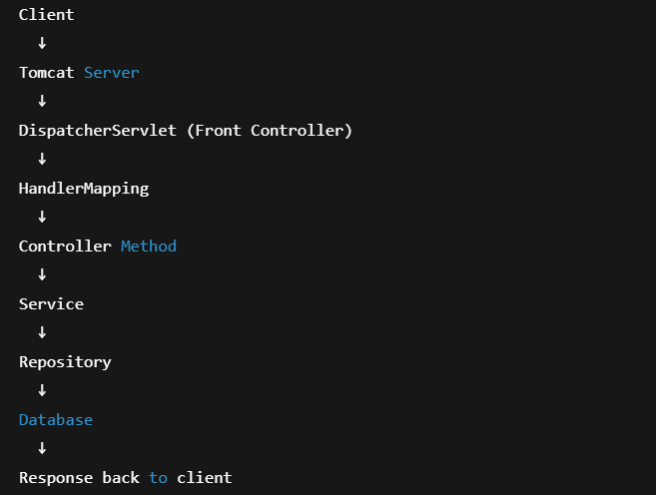

DispatcherServlet is the brain of Spring MVC.
It looks for:
- Controller classes
- Mapping annotations
- HTTP methods
- URL patterns

@Controller & @RequestMapping
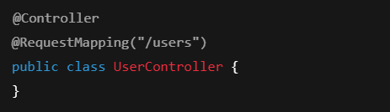
@Controller tells Spring:
This class contains request-handling methods.
@RequestMapping("/users") tells Spring:
All methods inside this controller start with /users

Mapping HTTP Requests
Old style
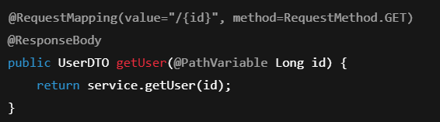@ResponseBody tells Spring:
Convert return value into JSON
@RestController
Because @ResponseBody is needed on every method, Spring introduced:
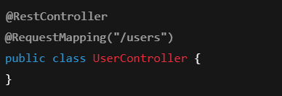
@RestController = @Controller + @ResponseBody
Now everything automatically returns JSON.

@GetMapping, @PostMapping, @PutMapping, @DeleteMapping
Instead of writing:
You write:

Same for:
- @PostMapping
- @PutMapping
- @DeleteMapping
These are just specialized RequestMapping annotations.

@RequestParam vs @PathVariable
Query Parameter
/users?id=10
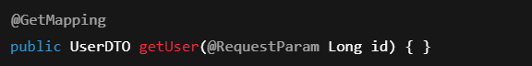
Path Variable
/users/10


@RequestBody
For POST / PUT APIs:
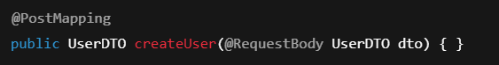Spring:
- Reads JSON
- Converts it into Java object

@Autowired (Dependency Injection)
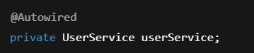
Spring injects:
- Service into Controller
- Repository into Service
You never create objects with new.

@Component, @Service, @Repository
Annotation | Purpose
@Component | Generic bean
@Service | Business logic
@Repository | Database access + exception translation
Spring uses these to apply:
- Transactions
- Persistence handling
- AOP

Interview-Critical Questions
Q1. Difference between @Controller and @RestController?
@RestController always returns JSON.
Q2. Difference between @RequestParam and @PathVariable?
Query string vs URL path.
Q3. Who handles all incoming requests?
DispatcherServlet.
Q4. Why @Repository instead of @Component?
Exception translation.

One-Line Summary
“Spring MVC annotations map HTTP requests to Java methods and wire controllers, services, and repositories together.”

